

**BIM PROJECT EXECUTION PLAN**

*FOR*

**IZMIR INTEGRATED HEALTH CAMPUS PROJECT**

**INTENSIVE CARE UNITS (ICU) BIM EXECUTION PLAN**

*DEVELOPED BY*

**GROUP İZMİR ÜÇLÜSÜ (IZU)**

TABLE OF CONTENTS

**SECTION A: DESCRIPTION OF BIM EXECUTION PLAN** 2

**SECTION B: PROJECT INFORMATION** 3

**SECTION C: PROJECT GOALS / BIM USES** 4

**SECTION D: BIM AND ORGANIZATIONAL ROLES, RESPONSIBILITIES** 5

**SECTION E: BIM PROCESS DESIGN** 6

**SECTION F: BIM INFORMATION EXCHANGES** 9

**SECTION G: MODEL STRUCTURE** 10

**SECTION H: COMMON DATA ENVIRONMENT** 13

**SECTION I: DATA SEGREGATION and FEDERATION STRATEGY** 14

**SECTION J: COLLABORATION PROCEDURES** 15

**SECTION K: QUALITY CONTROL** 17

**SECTION L: TECHNOLOGICAL INFRASTRUCTURE NEEDS** 18

**SECTION M: PROJECT ORIGIN POINT and COORDINATES** 19

**SECTION N: ATTACHMENTS** 20

# **SECTION A: DESCRIPTION OF BIM EXECUTION PLAN**

To successfully implement Building Information Modeling (BIM) on a project, the project team has developed this detailed BIM Project Execution Plan. The BIM Project Execution Plan defines uses for BIM on the project (e.g. design authoring, cost estimating, and design coordination), along with a detailed design of the process for executing BIM throughout the project lifecycle.

# **SECTION B: PROJECT INFORMATION**

1. **PROJECT OWNER**

*ISTANBUL TECHNICAL UNIVERSITY IYB501*

1. **PROJECT NAME**

*IZMIR BAYRAKLI INTEGRATED HEALTH CAMPUS PROJECT*

*INTENSIVE CARE UNITS (ICU)*

1. **PROJECT LOCATION AND ADDRESS:**

*İzmir Bayraklı Entegre Sağlık Kampüsü, Refik Şevket İnce Mahallesi 2148/11 Sokak, No:1/11 Bayraklı İZMİR*

1. **CONTRACT TYPE / DELIVERY METHOD:**

*Public Private Partnership, Build Operate Transfer Delivery Method*

1. **BRIEF PROJECT DESCRIPTION:**

*- Total Construction Area: (Y12-Y18 – X39-X44) 1920 m² in 631,320 m² in Main Hospital Building, MT2 block 4th – 5th floor*

* *Intensive Care Units: 18*

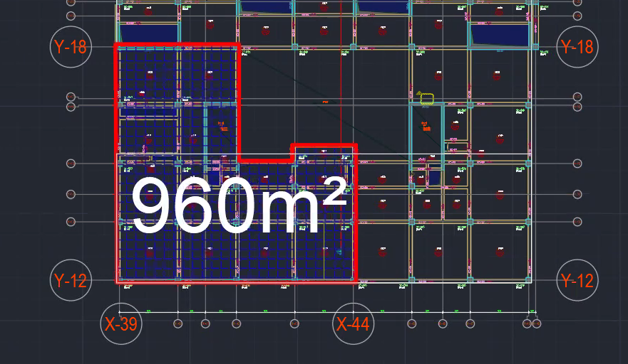

Base Point: Intersection of Y12 – X39 is 0,00 ; 0,00 coordinate all models.

1. **ADDITIONAL PROJECT INFORMATION:**

*Developing and coordinating the static, architectural, electrical and HVAC BIM models of the area between X39-X44 - Y12-Y18 axes on the 4th and 5th floors where the Intensive Care Units are located in the MT2 block of the Main Hospital building.*

1. **PROJECT SCHEDULE / PHASES / MILESTONES:**

|  |  |  |  |
| --- | --- | --- | --- |
| **PROJECT PHASE / MILESTONE** | **ESTIMATED START DATE** | **ESTIMATED COMPLETION DATE** | **PROJECT STAKEHOLDERS INVOLVED** |
| PRELIMINARY PLANNING | 26.10.2022 | 02.11.2022 |  |
| DESIGN DOCUMENTS | 01.11.2022 | 12.11.2022 |  |
| CLASHING DETECTION | 12.11.2022 | 20.11.2022 |  |
| DESIGN REVIEW | 21.11.2022 | 05.12.2022 | 07.12.2022 |

# **SECTION C: PROJECT GOALS / BIM USES**

1. **MAJOR BIM GOALS / OBJECTIVE:**

|  |  |  |
| --- | --- | --- |
| **PRIORITY** | **GOAL DESCRIPTION** | **POTENTIAL BIM USES** |
|  | Determining the scope of the project, preparing the work plan and assigning tasks. | PROGRAMMING |
|  | Building of BIM models | DESIGN AUTHORING |
|  | Clash detection | 3D COORDINATION |
|  | Scheduling and budgeting studies with the quantities obtained from the BIM model, creating a 4D model. | PHASE PLANNING  (4D MODELING) and COST ESTIMATION |

1. **BIM USES:**

|  |  |  |  |  |  |  |  |
| --- | --- | --- | --- | --- | --- | --- | --- |
| **X** | **PLAN** | **X** | **DESIGN** | **X** | **CONSTRUCT** | **X** | **OPERATE** |
| X | PROGRAMMING | X | DESIGN AUTHORING |  | SITE UTILIZATION PLANNING |  | BUILDING MAINTENANCE SCHEDULING |
|  | SITE ANALYSIS | X | DESIGN REVIEWS |  | CONSTRUCTION SYSTEM DESIGN |  | BUILDING SYSTEM ANALYSIS |
|  |  | X | 3D COORDINATION |  | 3D COORDINATION |  | ASSET MANAGEMENT |
|  |  |  | STRUCTURAL ANALYSIS |  | DIGITAL FABRICATION |  | SPACE MANAGEMENT / TRACKING |
|  |  |  | LIGHTING ANALYSIS |  | 3D CONTROL AND PLANNING |  | DISASTER PLANNING |
|  |  |  | ENERGY ANALYSIS |  | RECORD MODELING |  | RECORD MODELING |
|  |  |  | MECHANICAL ANALYSIS |  |  |  |  |
|  |  |  | OTHER ENG. ANALYSIS |  |  |  |  |
|  |  |  | SUSTAINABLITY (LEED) EVALUATION |  |  |  |  |
|  |  |  | CODE VALIDATION |  |  |  |  |
|  | PHASE PLANNING  (4D MODELING) | X | PHASE PLANNING  (4D MODELING) |  | PHASE PLANNING  (4D MODELING) |  | PHASE PLANNING  (4D MODELING) |
|  | COST ESTIMATION | X | COST ESTIMATION |  | COST ESTIMATION |  | COST ESTIMATION |
|  | EXISTING CONDITIONS MODELING |  | EXISTING CONDITIONS MODELING |  | EXISTING CONDITIONS MODELING |  | EXISTING CONDITIONS MODELING |

# **SECTION D: BIM AND ORGANIZATIONAL ROLES, RESPONSIBILITIES**

1. **BIM ROLES AND KEY PROJECT CONTACTS:**

|  |  |  |  |  |  |
| --- | --- | --- | --- | --- | --- |
| **ROLE** | **ORGANIZATION** | **CONTACT NAME** | **LOCATION** | **E-MAIL** | **PHONE** |
| Project Manager | İzmir Üçlüsü (IZU) | M. Selim Soysal (MSS) | İzmir | [SOYSAL22@ITU.EDU.TR](mailto:SOYSAL22@ITU.EDU.TR) | +90555 5153180 |
| BIM Manager | İzmir Üçlüsü (IZU) | Ali Erişir  (ALE) | İstanbul | [ERISIR22@ITU.EDU.TR](mailto:ERISIR22@ITU.EDU.TR) | +90507 8773866 |
| Structural Discipline Lead | İzmir Üçlüsü (IZU) | Uğurcan Çakal  (UCK) | İzmir | [CAKAL22@ITU.EDU.TR](mailto:CAKAL22@ITU.EDU.TR) | +90530 3009556 |
| Architectural Discipline Lead | İzmir Üçlüsü (IZU) | Eray Uzun  (ERY) | İzmir | [UZUNE22@ITU.EDU.TR](mailto:UZUNE22@ITU.EDU.TR) | +90555 7695797 |
| Mechanical and Electrical Discipline Leads | İzmir Üçlüsü (IZU) | Ali Erişir  (ALE) | İstanbul | [ERISIR22@ITU.EDU.TR](mailto:ERISIR22@ITU.EDU.TR) | +90507 8773866 |
| Mechanical and Electrical Discipline Leads | İzmir Üçlüsü (IZU) | M. Selim Soysal  (MSS) | İzmir | [SOYSAL22@ITU.EDU.TR](mailto:SOYSAL22@ITU.EDU.TR) | +90555 5153180 |

1. **BIM ROLES AND RESPONSIBILITIES:**

Project Manager: Control of project delivery processes, resolution of disruptions and timely realization of the operation.

BIM Manager: Coordination of information exchange of the models to be created, determination and requesting of the required drawings and materials, control of the flow towards BIM output targets.

Disciplinary Leads: Co-responsible owner for the creation and correction of models in the relevant discipline and their correct role in BIM deliverables.

1. **BIM USE STAFFING:**

|  |  |  |  |  |  |
| --- | --- | --- | --- | --- | --- |
| **BIM USE** | **ORGANIZATION** | **NUMBER OF TOTAL STAFF FOR BIM USE** | **ESTIMATED WORKER HOURS** | **LOCATION(S)** | **LEAD CONTACT** |
| DESIGN AUTHORING and REVIEWS | IZU | 4 | 10 | Online | BIM Manager |
| 3D COORDINATION | IZU | 4 | 2 | Online | BIM Manager |
| PHASE PLANNING  (4D MODELING) | IZU | 4 | 6 | Online | Project Manager |
| COST ESTIMATION | IZU | 4 | 6 | Online | Project Manager |

# **SECTION E: BIM PROCESS DESIGN**

1. **LEVEL ONE PROCESS OVERVIEW MAP: ATTACHMENT 2**

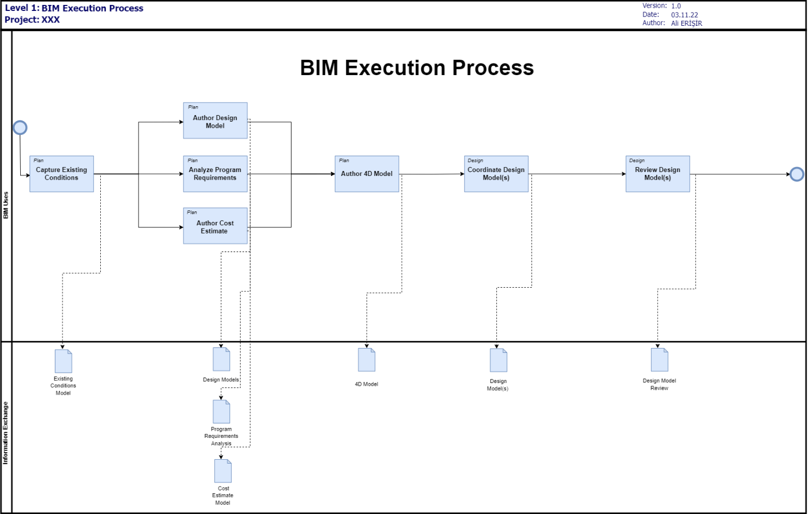

1. **LIST OF LEVEL TWO – DETAILED BIM USE PROCESS MAP(S): ATTACHMENT 3**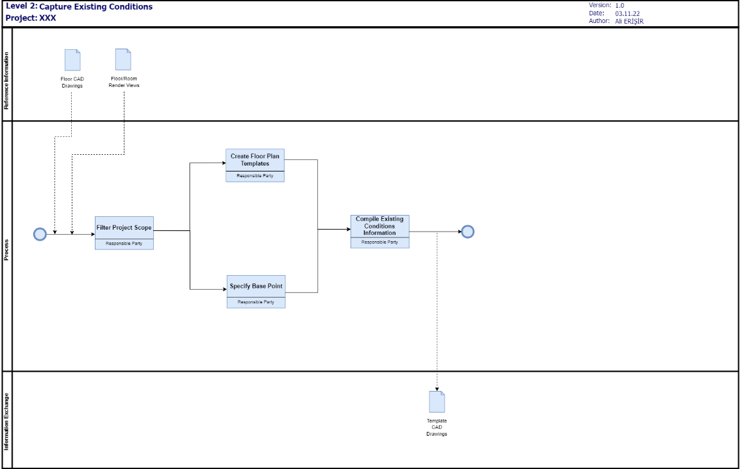

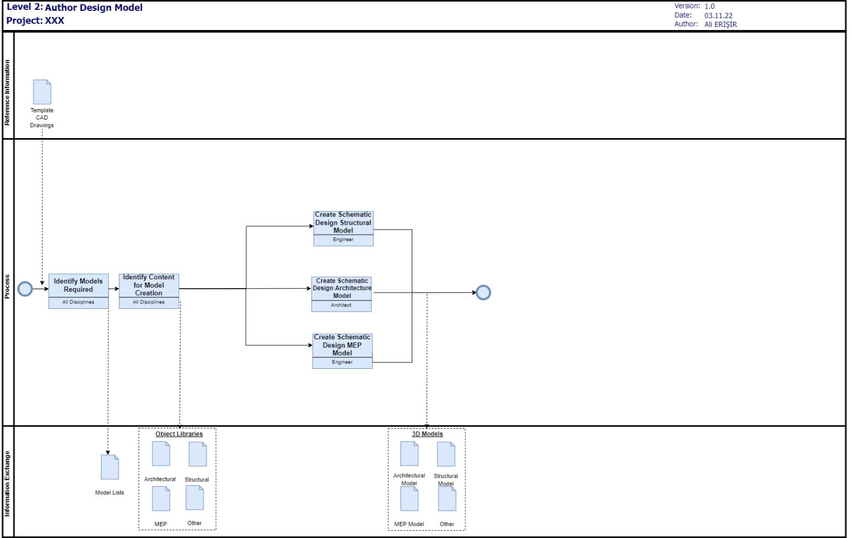 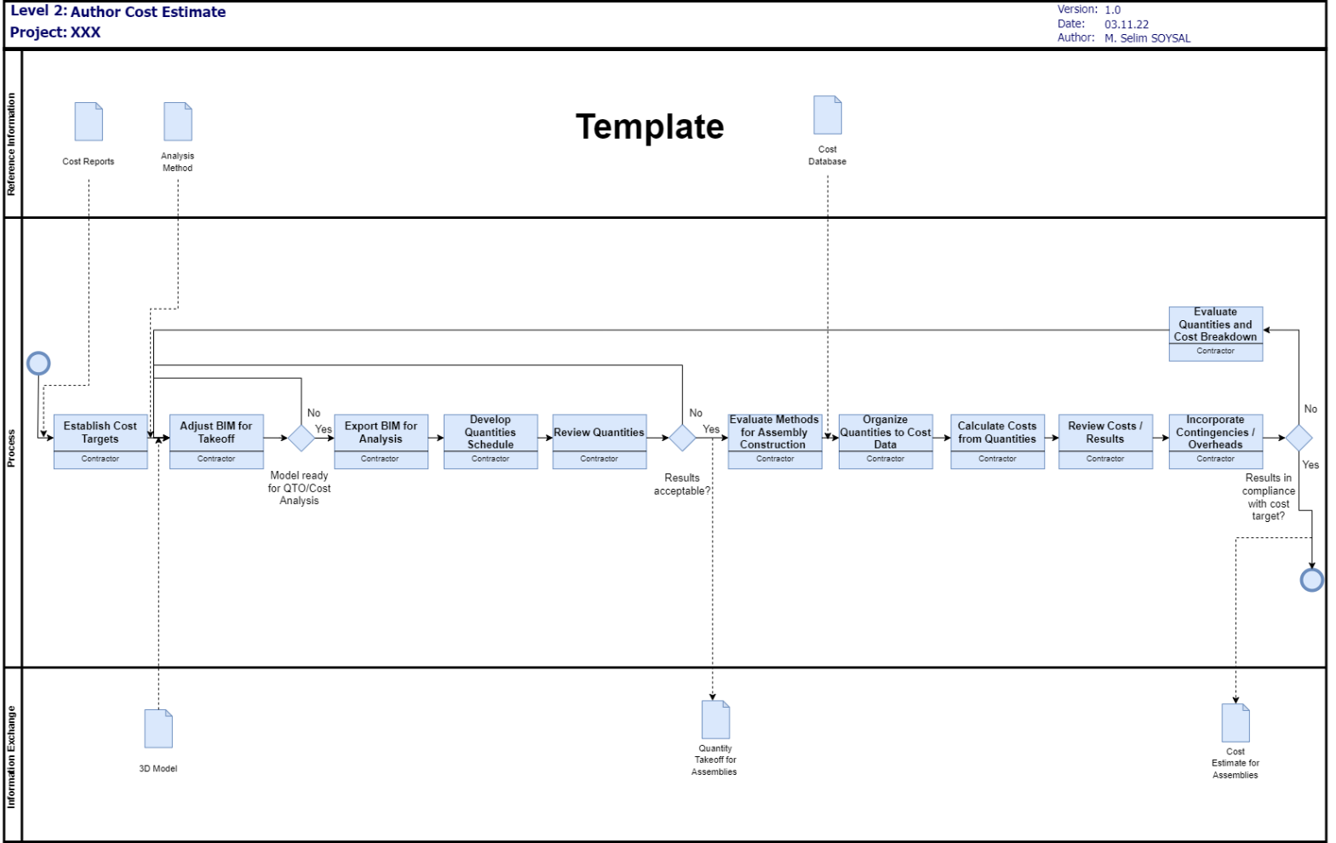 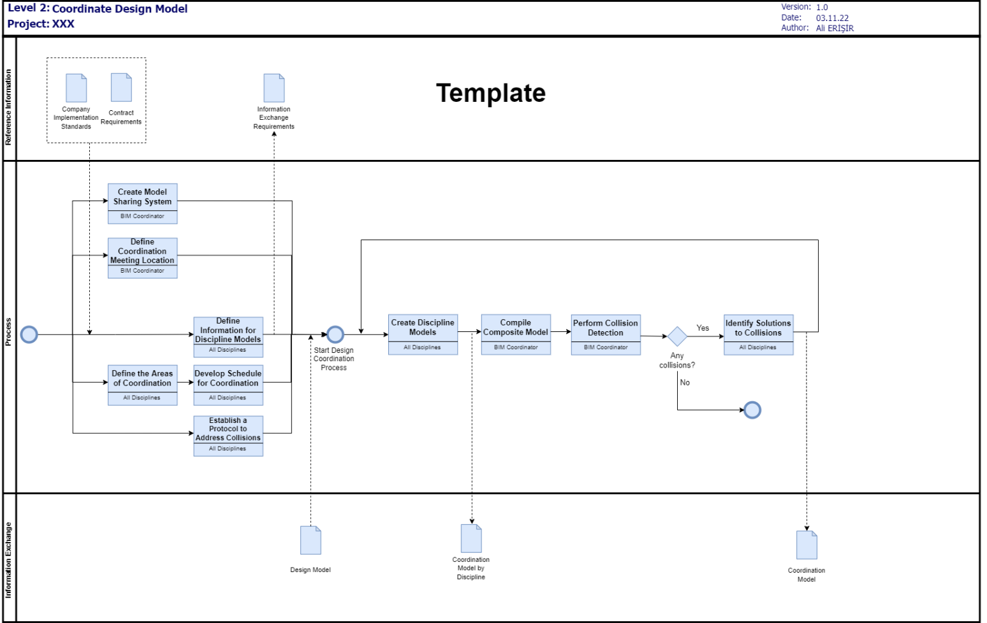



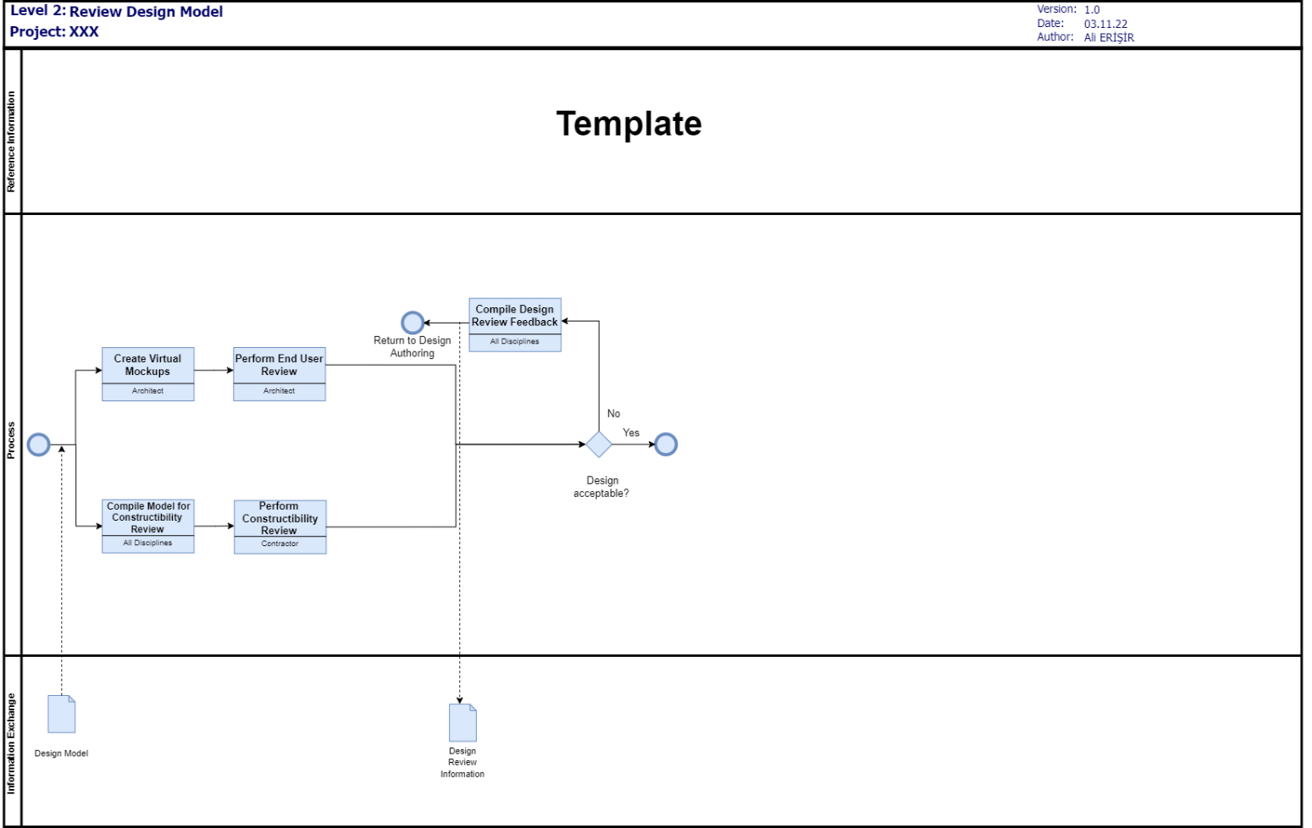

# **SECTION F: BIM INFORMATION EXCHANGES**

1. **LIST OF INFORMATION EXCHANGE WORKSHEET(S): ATTACHMENT 4**
2. **MODEL DEFINITION WORKSHEET: ATTACHMENT 5**

# **SECTION G: MODEL STRUCTURE**

1. **FILE NAMING STRUCTURE:**

|  |  |  |  |  |  |  |
| --- | --- | --- | --- | --- | --- | --- |
| **PROJECT NAME** | **FLOOR** | **DISCIPLINE CODE** | **TYPE CODE** | **TYPE DEFINITION** | **LOCATION CODE** | **NUMBER DESCRIPTION** |
| **IZU** | **L4** | **ARC** | **AF** | Animation file (of a model) | **CICU-098** | **00** |
|  | **L5** | **STA** | **CM** | Combined model (combined multidiscipline model) |  |  |
|  |  | **MEC** | **CR** | Specific for the Clash Process |  |  |
|  |  | **ELC** | **DR** | 2D |  |  |
|  |  |  | **M2** | 2D Model File |  |  |
|  |  |  | **M3** | 3D Model File |  |  |
|  |  |  | **MR** | Model rendition file for other renditions |  |  |
|  |  |  | **VS** | Visualization file (of a model) |  |  |
|  |  |  |  |  |  |  |
|  |  |  | **BQ** | Bill of quantities |  |  |
|  |  |  | **CA** | Calculations |  |  |
|  |  |  | **CO** | Correspondence |  |  |
|  |  |  | **CP** | Cost plan |  |  |
|  |  |  | **DB** | Database |  |  |
|  |  |  | **FN** | File Note |  |  |
|  |  |  | **HS** | Health and safety |  |  |
|  |  |  | **IE** | Information exchange file |  |  |
|  |  |  | **MI** | Minutes / action notes |  |  |
|  |  |  | **MS** | Method statement |  |  |
|  |  |  | **PP** | Presentation |  |  |
|  |  |  | **PR** | Programme |  |  |
|  |  |  | **RD** | Room data sheet |  |  |
|  |  |  | **RI** | Request for information |  |  |
|  |  |  | **RP** | Report |  |  |
|  |  |  | **SA** | Schedule of accommodation |  |  |
|  |  |  | **SH** | Schedule |  |  |
|  |  |  | **SN** | Snagging list |  |  |
|  |  |  | **SP** | Specification |  |  |
|  |  |  | **SU** | Survey |  |  |

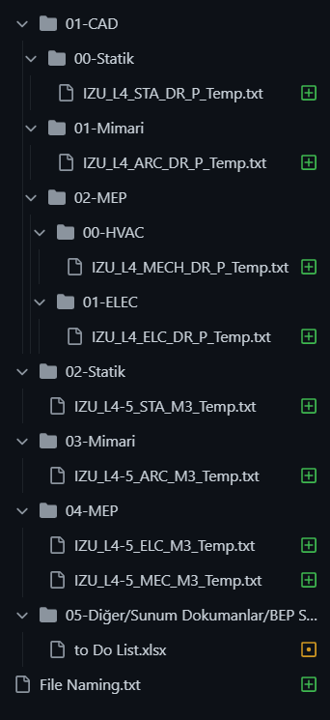

1. **MODEL STRUCTURE:**



# **SECTION H: COMMON DATA ENVIRONMENT**

1. **…….**

# **SECTION I: DATA SEGREGATION AND FEDERATION STRATEGY**

1. **…….**

# **SECTION J: COLLABORATION PROCEDURES**

1. **COLLABORATION STRATEGY:**

Only one person is assigned to be responsible for each model under the disciplines and created in the relevant discipline file. At regular meetings, these models are combined under disciplines. The files shared via GITHUB are uploaded to the system in a controlled manner, subject to the approval of at least one other person, and filed in the workspace ready to be linked.

1. **MEETING PROCEDURES:**

The meeting days will be Sunday, Monday and Thursday. The duration will not exceed 1 hour. The content is limited to the solutions of the problems that have arisen, the finalization of the decisions that need to be taken jointly and the determination of the path to be followed. Minutes of each meeting will be published.

1. **MODEL DELIVERY SCHEDULE OF INFORMATION EXCHANGE FOR SUBMISSION AND APPROVAL:**

Yüklenen dosyalar

1. **INTERACTIVE WORKSPACE:**

GitHub.com

1. **ELECTRONIC COMMUNICATION PROCEDURES:**

# **SECTION K: QUALITY CONTROL**

1. **OVERALL STRATEGY FOR QUALITY CONTROL:**

*The base point, standards and specified levels of detail will be maintained.*

1. **QUALITY CONTROL CHECKS:**

|  |  |
| --- | --- |
| **CHECKS** | **DEFINITATION** |
| VISUAL CHECK | Ensure there are no unintended model components and the design intent has been followed |
| CLASH CHECK | Detect problems in the model where two building components are clashing including soft and hard |

1. **MODEL ACCURACY AND TOLERANCES:**

|  |  |
| --- | --- |
| **Include Model of** | **Tolerances** |
| Mechanical | 0,02 m |
| Electrical | 0,02 m |
| Architectural | 0,02 m |
| Structural | 0,05 m |

# **SECTION L: TECHNOLOGICAL INFRASTRUCTURE NEEDS**

1. **SOFTWARE:**

|  |  |  |  |
| --- | --- | --- | --- |
| **BIM USE** | **DISCIPLINE** | **SOFTWARE** | **VERSION** |
| DESIGN AUTHORING and REVIEWS | All Disciplines | Revit | Revit 2022 |
| 3D COORDINATION | All Disciplines | Revit, Navisworks | Revit 2022  Navisworks Manage 2022 |
| PHASE PLANNING  (4D MODELING) | All Discipline | Revit, Primavera P6 | REVIT 2022, P6 17 |
| COST ESTIMATION | All Discipline | Revit, Primavera P6 | REVIT 2022  MS Excel 2016 |

1. **MODELING CONTENT AND REFERENCE INFORMATION**

|  |  |  |  |
| --- | --- | --- | --- |
| **BIM USE** | **DISCIPLINE** | **MODELING CONTENT /**  **REFERENCE INFORMATION** | **VERSION** |
| DESIGN AUTHORING and REVIEWS | Structural | Building models of column, beam, slab, shared wall | Revit 2022 |
| DESIGN AUTHORING and REVIEWS | Architect | Building models of wall, door, window, medical bed, facade cladding, floor covering, suspended ceiling | Revit 2022 |
| DESIGN AUTHORING and REVIEWS | Mechanical | Building models of ventilation duct, grille, medical piping, patient bedside unit, | Revit 2022 |
| DESIGN AUTHORING and REVIEWS | Electrical | Building model of cable tray | Revit 2022 |
| 3D COORDINATION | All Disciplines | Clash Detection in one coordinate system between models defined on Clash Matris | Revit 2022  Navisworks 2022 |
| PHASE PLANNING  (4D MODELING) | All Disciplines | Merging of the disciplines models with construction phases and schedules | Navisworks 2022  Primavera P6 |
| COST ESTIMATION | Construction Manager | Use of other trades models to create a detail cost estimation | Revit 2022  MS Excel 2016 |

# **SECTION M: PROJECT ORIGIN POINT AND COORDINATES**

1. **MEASUREMENT AND COORDINATE SYSTEMS:**

In all discipline models, the 0,00; 0,00 point will be created in metric order by aligning it to the Y12 - X39 axes coincidence.

# **SECTION N: ATTACHMENTS**

1. BIM USE SELECTION WORKSHEET [FROM SECTION D]
2. LEVEL 1 PROCESS OVERVIEW MAP [FROM SECTION F]
3. LEVEL 2 DETAILED BIM USE PROCESS MAP(S) [FROM SECTION F]
4. INFORMATION EXCHANGE REQUIREMENT WORKSHEET(S) [FROM SECTION G]
5. MODEL DEFINITION WORKSHEET [FROM SECTION G]
6. DEVELOPED DOCUMENTS / CONTRACTS [FROM SECTION H]